Kode untuk pindah ke Form JendelaTamu dengan mengklik btnLihatDataTamu

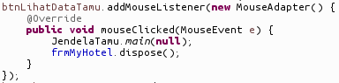

Kode untuk pindah ke Form JendelaKamar dengan mengklik btnLihatDataKamar

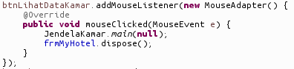

Kelas Kamar

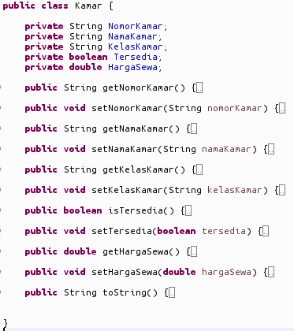

Kelas Tamu

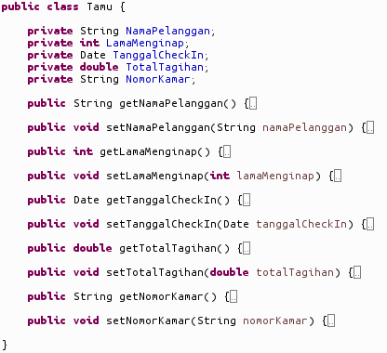

Fungsi untuk mendapatkan daftar kamar yang ada di hotel.

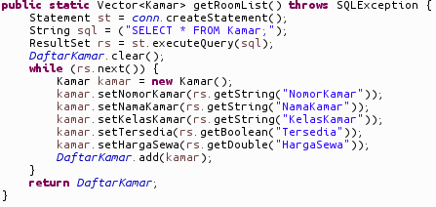

Fungsi menambahkan kamar ke dalam database MySQL.

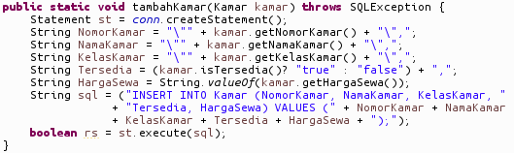

Fungsi menambahkan tamu ke dalam database MySQL.

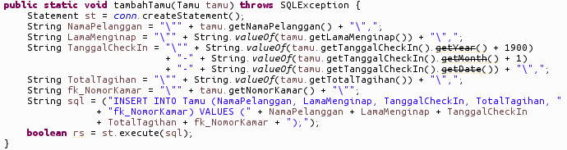

Fungsi membaca data Kamar dari input user dan menambahnya ke database.

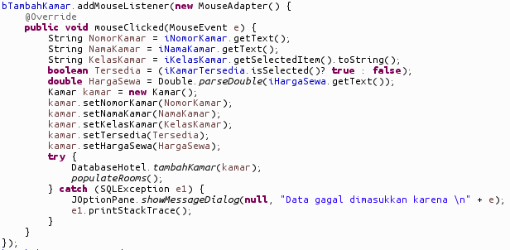

Fungsi membaca data Tamu dari input user dan menambahnya ke database.

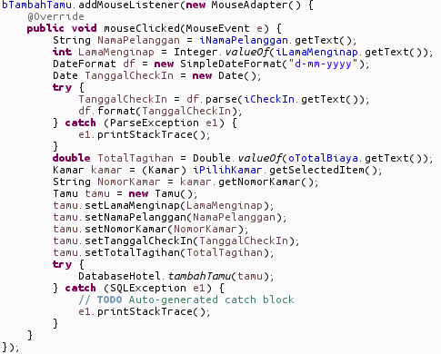

Jendela Utama

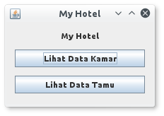

Jendela Kamar

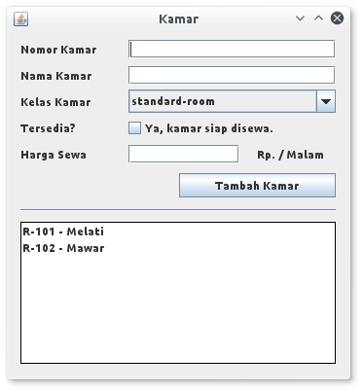

Jendela Tamu

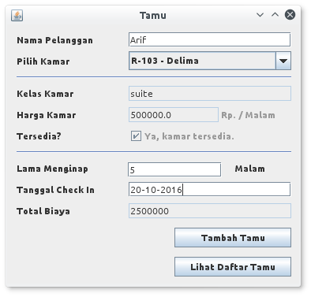

Eksekusi MySQL

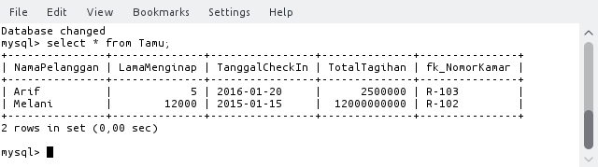

**File : DatabaseHotel.java**

package com.myhotel;

import java.sql.Connection;

import java.sql.ResultSet;

import java.sql.SQLException;

import java.sql.Statement;

import java.util.Vector;

import com.mysql.jdbc.jdbc2.optional.MysqlDataSource;

public class DatabaseHotel {

public static Connection conn = null;

private static Vector<Kamar> DaftarKamar = new Vector<Kamar>();

public static void init() throws SQLException {

MysqlDataSource dataSource = new MysqlDataSource();

dataSource.setUser("root");

dataSource.setPassword("");

dataSource.setServerName("localhost");

dataSource.setDatabaseName("myhotel");

conn = dataSource.getConnection();

}

public static Vector<Kamar> getRoomList() throws SQLException {

Statement st = conn.createStatement();

String sql = ("SELECT * FROM Kamar;");

ResultSet rs = st.executeQuery(sql);

DaftarKamar.clear();

while (rs.next()) {

Kamar kamar = new Kamar();

kamar.setNomorKamar(rs.getString("NomorKamar"));

kamar.setNamaKamar(rs.getString("NamaKamar"));

kamar.setKelasKamar(rs.getString("KelasKamar"));

kamar.setTersedia(rs.getBoolean("Tersedia"));

kamar.setHargaSewa(rs.getDouble("HargaSewa"));

DaftarKamar.add(kamar);

}

return DaftarKamar;

}

public static void tambahKamar(Kamar kamar) throws SQLException {

Statement st = conn.createStatement();

String NomorKamar = "\"" + kamar.getNomorKamar() + "\",";

String NamaKamar = "\"" + kamar.getNamaKamar() + "\",";

String KelasKamar = "\"" + kamar.getKelasKamar() + "\",";

String Tersedia = (kamar.isTersedia()? "true" : "false") + ",";

String HargaSewa = String.valueOf(kamar.getHargaSewa());

String sql = ("INSERT INTO Kamar (NomorKamar, NamaKamar, KelasKamar, "

+ "Tersedia, HargaSewa) VALUES (" + NomorKamar + NamaKamar

+ KelasKamar + Tersedia + HargaSewa + ");");

boolean rs = st.execute(sql);

}

public static void tambahTamu(Tamu tamu) throws SQLException {

Statement st = conn.createStatement();

String NamaPelanggan = "\"" + tamu.getNamaPelanggan() + "\",";

String LamaMenginap = "\"" + String.valueOf(tamu.getLamaMenginap()) + "\",";

String TanggalCheckIn = "\"" + String.valueOf(tamu.getTanggalCheckIn().getYear() + 1900)

+ "-" + String.valueOf(tamu.getTanggalCheckIn().getMonth() + 1)

+ "-" + String.valueOf(tamu.getTanggalCheckIn().getDate()) + "\",";

String TotalTagihan = "\"" + String.valueOf(tamu.getTotalTagihan()) + "\",";

String fk_NomorKamar = "\"" + tamu.getNomorKamar() + "\"";

String sql = ("INSERT INTO Tamu (NamaPelanggan, LamaMenginap, TanggalCheckIn, TotalTagihan, "

+ "fk_NomorKamar) VALUES (" + NamaPelanggan + LamaMenginap + TanggalCheckIn

+ TotalTagihan + fk_NomorKamar + ");");

boolean rs = st.execute(sql);

}

}

**File : JendelaKamar.java**

package com.myhotel;

import java.awt.EventQueue;

import javax.swing.JFrame;

import java.awt.event.WindowAdapter;

import java.awt.event.WindowEvent;

import java.sql.SQLException;

import java.util.List;

import java.util.Vector;

import javax.swing.JLabel;

import javax.swing.JTextField;

import javax.swing.JCheckBox;

import javax.swing.JButton;

import javax.swing.JList;

import javax.swing.JOptionPane;

import javax.swing.border.LineBorder;

import javax.xml.crypto.KeySelector.Purpose;

import java.awt.Color;

import javax.swing.JSeparator;

import javax.swing.JComboBox;

import javax.swing.DefaultComboBoxModel;

import javax.swing.DefaultListModel;

import java.awt.event.MouseAdapter;

import java.awt.event.MouseEvent;

public class JendelaKamar {

private JFrame frmKamar;

private JTextField iNomorKamar;

private JTextField iNamaKamar;

private JTextField iHargaSewa;

private JCheckBox iKamarTersedia;

private JButton bTambahKamar;

private static JList<Kamar> oDaftarKamar;

private JComboBox iKelasKamar;

private static Vector<Kamar> daftarKamar = new Vector<Kamar>();

/**

* Launch the application.

*/

public static void main(String[] args) {

EventQueue.invokeLater(new Runnable() {

public void run() {

try {

JendelaKamar window = new JendelaKamar();

window.frmKamar.setVisible(true);

} catch (Exception e) {

e.printStackTrace();

}

}

});

}

public static void populateRooms() throws SQLException {

daftarKamar = DatabaseHotel.getRoomList();

oDaftarKamar.setListData(daftarKamar);

}

/**

* Create the application.

* @throws SQLException

*/

public JendelaKamar() throws SQLException {

initialize();

populateRooms();

}

/**

* Initialize the contents of the frame.

*/

private void initialize() {

frmKamar = new JFrame();

frmKamar.setTitle("Kamar");

frmKamar.addWindowListener(new WindowAdapter() {

@Override

public void windowClosed(WindowEvent e) {

JendelaUtama.main(null);

frmKamar.dispose();

}

});

frmKamar.setBounds(100, 100, 353, 381);

frmKamar.setDefaultCloseOperation(JFrame.DISPOSE_ON_CLOSE);

frmKamar.getContentPane().setLayout(null);

JLabel lblNomorKamar = new JLabel("Nomor Kamar");

lblNomorKamar.setBounds(12, 12, 93, 15);

frmKamar.getContentPane().add(lblNomorKamar);

JLabel lblNamaKamar = new JLabel("Nama Kamar");

lblNamaKamar.setBounds(12, 39, 93, 15);

frmKamar.getContentPane().add(lblNamaKamar);

JLabel lblKelasKamar = new JLabel("Kelas Kamar");

lblKelasKamar.setBounds(12, 66, 93, 15);

frmKamar.getContentPane().add(lblKelasKamar);

JLabel lblTersedia = new JLabel("Tersedia?");

lblTersedia.setBounds(12, 93, 93, 15);

frmKamar.getContentPane().add(lblTersedia);

JLabel lblHargaSewa = new JLabel("Harga Sewa");

lblHargaSewa.setBounds(12, 120, 93, 15);

frmKamar.getContentPane().add(lblHargaSewa);

iNomorKamar = new JTextField();

iNomorKamar.setBounds(123, 10, 213, 19);

frmKamar.getContentPane().add(iNomorKamar);

iNomorKamar.setColumns(10);

iNamaKamar = new JTextField();

iNamaKamar.setBounds(123, 37, 213, 19);

frmKamar.getContentPane().add(iNamaKamar);

iNamaKamar.setColumns(10);

iKamarTersedia = new JCheckBox("Ya, kamar siap disewa.");

iKamarTersedia.setBounds(119, 89, 217, 23);

frmKamar.getContentPane().add(iKamarTersedia);

iHargaSewa = new JTextField();

iHargaSewa.setBounds(123, 118, 114, 19);

frmKamar.getContentPane().add(iHargaSewa);

iHargaSewa.setColumns(10);

JLabel lblRpMalam = new JLabel("Rp. / Malam");

lblRpMalam.setBounds(255, 120, 81, 15);

frmKamar.getContentPane().add(lblRpMalam);

bTambahKamar = new JButton("Tambah Kamar");

bTambahKamar.addMouseListener(new MouseAdapter() {

@Override

public void mouseClicked(MouseEvent e) {

String NomorKamar = iNomorKamar.getText();

String NamaKamar = iNamaKamar.getText();

String KelasKamar = iKelasKamar.getSelectedItem().toString();

boolean Tersedia = (iKamarTersedia.isSelected()? true : false);

double HargaSewa = Double.parseDouble(iHargaSewa.getText());

Kamar kamar = new Kamar();

kamar.setNomorKamar(NomorKamar);

kamar.setNamaKamar(NamaKamar);

kamar.setKelasKamar(KelasKamar);

kamar.setTersedia(Tersedia);

kamar.setHargaSewa(HargaSewa);

try {

DatabaseHotel.tambahKamar(kamar);

populateRooms();

} catch (SQLException e1) {

JOptionPane.showMessageDialog(null, "Data gagal dimasukkan karena \n" + e);

e1.printStackTrace();

}

}

});

bTambahKamar.setBounds(175, 147, 161, 25);

frmKamar.getContentPane().add(bTambahKamar);

oDaftarKamar = new JList<Kamar>();

oDaftarKamar.setBorder(new LineBorder(new Color(0, 0, 0)));

oDaftarKamar.setBounds(12, 197, 324, 146);

frmKamar.getContentPane().add(oDaftarKamar);

JSeparator separator = new JSeparator();

separator.setBounds(12, 184, 324, 13);

frmKamar.getContentPane().add(separator);

iKelasKamar = new JComboBox();

iKelasKamar.setModel(new DefaultComboBoxModel(new String[] {"standardroom", "superior", "deluxe", "suite", "presidential"}));

iKelasKamar.setBounds(123, 61, 213, 24);

frmKamar.getContentPane().add(iKelasKamar);

}

}

**File : JendelaTamu.java**

package com.myhotel;

import java.awt.EventQueue;

import javax.swing.JFrame;

import java.awt.event.WindowAdapter;

import java.awt.event.WindowEvent;

import java.sql.SQLException;

import java.text.DateFormat;

import java.text.ParseException;

import java.text.SimpleDateFormat;

import java.util.Date;

import java.util.Vector;

import javax.swing.JLabel;

import javax.swing.JSeparator;

import javax.swing.JTextField;

import javax.swing.JComboBox;

import javax.swing.JCheckBox;

import javax.swing.JButton;

import java.awt.event.ActionListener;

import java.awt.event.ActionEvent;

import java.awt.event.KeyAdapter;

import java.awt.event.KeyEvent;

import java.awt.event.MouseAdapter;

import java.awt.event.MouseEvent;

public class JendelaTamu {

private JFrame frmTamu;

private JTextField iNamaPelanggan;

private JTextField oKelasKamar;

private JTextField oHargaKamar;

private JTextField iLamaMenginap;

private JTextField iCheckIn;

private JTextField oTotalBiaya;

private JComboBox iPilihKamar;

private JCheckBox oKamarTersedia;

private JButton bTambahTamu;

private JButton bLihatTamu;

private static Vector<Kamar> daftarKamar = new Vector<Kamar>();

/**

* Launch the application.

*/

public static void main(String[] args) {

EventQueue.invokeLater(new Runnable() {

public void run() {

try {

JendelaTamu window = new JendelaTamu();

window.frmTamu.setVisible(true);

} catch (Exception e) {

e.printStackTrace();

}

}

});

}

public static void populateRooms() throws SQLException {

daftarKamar = DatabaseHotel.getRoomList();

}

/**

* Create the application.

* @throws SQLException

*/

public JendelaTamu() throws SQLException {

initialize();

populateInfoKamar();

}

private void populateInfoKamar() {

Kamar kamar = (Kamar) iPilihKamar.getSelectedItem();

oKelasKamar.setText(kamar.getKelasKamar());

oHargaKamar.setText(String.valueOf(kamar.getHargaSewa()));

oKamarTersedia.setSelected(kamar.isTersedia());

}

/**

* Initialize the contents of the frame.

* @throws SQLException

*/

private void initialize() throws SQLException {

frmTamu = new JFrame();

frmTamu.addWindowListener(new WindowAdapter() {

@Override

public void windowClosed(WindowEvent e) {

JendelaUtama.main(null);

frmTamu.dispose();

}

});

frmTamu.setTitle("Tamu");

frmTamu.setBounds(100, 100, 374, 357);

frmTamu.setDefaultCloseOperation(JFrame.DISPOSE_ON_CLOSE);

frmTamu.getContentPane().setLayout(null);

JLabel lblNamaPelanggan = new JLabel("Nama Pelanggan");

lblNamaPelanggan.setBounds(12, 12, 129, 15);

frmTamu.getContentPane().add(lblNamaPelanggan);

JLabel lblPilihKamar = new JLabel("Pilih Kamar");

lblPilihKamar.setBounds(12, 39, 129, 15);

frmTamu.getContentPane().add(lblPilihKamar);

JSeparator separator = new JSeparator();

separator.setBounds(12, 66, 348, 2);

frmTamu.getContentPane().add(separator);

JLabel lblKelasKamar = new JLabel("Kelas Kamar");

lblKelasKamar.setBounds(12, 80, 129, 15);

frmTamu.getContentPane().add(lblKelasKamar);

JLabel lblHargaKamar = new JLabel("Harga Kamar");

lblHargaKamar.setBounds(12, 107, 108, 15);

frmTamu.getContentPane().add(lblHargaKamar);

JLabel lblTersedia = new JLabel("Tersedia?");

lblTersedia.setBounds(12, 134, 108, 15);

frmTamu.getContentPane().add(lblTersedia);

JSeparator separator_2 = new JSeparator();

separator_2.setBounds(12, 161, 348, 2);

frmTamu.getContentPane().add(separator_2);

JLabel lblLamaMenginap_1 = new JLabel("Lama Menginap");

lblLamaMenginap_1.setBounds(12, 175, 129, 15);

frmTamu.getContentPane().add(lblLamaMenginap_1);

JLabel lblLamaMenginap = new JLabel("Lama Menginap");

lblLamaMenginap.setBounds(12, 175, 76, 15);

frmTamu.getContentPane().add(lblLamaMenginap);

iNamaPelanggan = new JTextField();

iNamaPelanggan.setBounds(154, 10, 206, 19);

frmTamu.getContentPane().add(iNamaPelanggan);

iNamaPelanggan.setColumns(10);

populateRooms();

iPilihKamar = new JComboBox(daftarKamar.toArray());

iPilihKamar.addActionListener(new ActionListener() {

public void actionPerformed(ActionEvent e) {

populateInfoKamar();

}

});

iPilihKamar.setBounds(154, 34, 206, 24);

frmTamu.getContentPane().add(iPilihKamar);

oKelasKamar = new JTextField();

oKelasKamar.setEditable(false);

oKelasKamar.setBounds(154, 78, 206, 19);

frmTamu.getContentPane().add(oKelasKamar);

oKelasKamar.setColumns(10);

oHargaKamar = new JTextField();

oHargaKamar.setEditable(false);

oHargaKamar.setBounds(154, 105, 114, 19);

frmTamu.getContentPane().add(oHargaKamar);

oHargaKamar.setColumns(10);

oKamarTersedia = new JCheckBox("Ya, kamar tersedia.");

oKamarTersedia.setEnabled(false);

oKamarTersedia.setBounds(153, 130, 177, 23);

frmTamu.getContentPane().add(oKamarTersedia);

JLabel lblRpMalam = new JLabel("Rp. / Malam");

lblRpMalam.setEnabled(false);

lblRpMalam.setBounds(271, 107, 74, 15);

frmTamu.getContentPane().add(lblRpMalam);

iLamaMenginap = new JTextField();

iLamaMenginap.addKeyListener(new KeyAdapter() {

@Override

public void keyReleased(KeyEvent e) {

if (!iLamaMenginap.getText().isEmpty()) {

double LamaMenginap = Double.valueOf(iLamaMenginap.getText());

double TarifSewa = ((Kamar) iPilihKamar.getSelectedItem()).getHargaSewa();

oTotalBiaya.setText(String.format("%.0f", LamaMenginap * TarifSewa));

} else {

oTotalBiaya.setText("0");

}

}

});

iLamaMenginap.setBounds(153, 175, 119, 19);

frmTamu.getContentPane().add(iLamaMenginap);

iLamaMenginap.setColumns(10);

JLabel lblMalam = new JLabel("Malam");

lblMalam.setBounds(288, 175, 57, 15);

frmTamu.getContentPane().add(lblMalam);

JLabel lblTanggalCheckIn = new JLabel("Tanggal Check In");

lblTanggalCheckIn.setBounds(12, 202, 129, 15);

frmTamu.getContentPane().add(lblTanggalCheckIn);

JLabel lblTotalBiaya = new JLabel("Total Biaya");

lblTotalBiaya.setBounds(12, 229, 129, 15);

frmTamu.getContentPane().add(lblTotalBiaya);

iCheckIn = new JTextField();

iCheckIn.setBounds(154, 200, 206, 19);

frmTamu.getContentPane().add(iCheckIn);

iCheckIn.setColumns(10);

oTotalBiaya = new JTextField();

oTotalBiaya.setEditable(false);

oTotalBiaya.setBounds(154, 227, 206, 19);

frmTamu.getContentPane().add(oTotalBiaya);

oTotalBiaya.setColumns(10);

bTambahTamu = new JButton("Tambah Tamu");

bTambahTamu.addMouseListener(new MouseAdapter() {

@Override

public void mouseClicked(MouseEvent e) {

String NamaPelanggan = iNamaPelanggan.getText();

int LamaMenginap = Integer.valueOf(iLamaMenginap.getText());

DateFormat df = new SimpleDateFormat("d-mm-yyyy");

Date TanggalCheckIn = new Date();

try {

TanggalCheckIn = df.parse(iCheckIn.getText());

df.format(TanggalCheckIn);

} catch (ParseException e1) {

e1.printStackTrace();

}

double TotalTagihan = Double.valueOf(oTotalBiaya.getText());

Kamar kamar = (Kamar) iPilihKamar.getSelectedItem();

String NomorKamar = kamar.getNomorKamar();

Tamu tamu = new Tamu();

tamu.setLamaMenginap(LamaMenginap);

tamu.setNamaPelanggan(NamaPelanggan);

tamu.setNomorKamar(NomorKamar);

tamu.setTanggalCheckIn(TanggalCheckIn);

tamu.setTotalTagihan(TotalTagihan);

try {

DatabaseHotel.tambahTamu(tamu);

} catch (SQLException e1) {

// TODO Auto-generated catch block

e1.printStackTrace();

}

}

});

bTambahTamu.setBounds(212, 258, 148, 25);

frmTamu.getContentPane().add(bTambahTamu);

bLihatTamu = new JButton("Lihat Daftar Tamu");

bLihatTamu.setBounds(212, 295, 148, 25);

frmTamu.getContentPane().add(bLihatTamu);

}

}

**File : JendelaUtama.java**

package com.myhotel;

import java.awt.EventQueue;

import javax.swing.JFrame;

import javax.swing.JLabel;

import javax.swing.JButton;

import javax.swing.SwingConstants;

import java.awt.event.MouseAdapter;

import java.awt.event.MouseEvent;

public class JendelaUtama {

private JFrame frmMyHotel;

/**

* Launch the application.

*/

public static void main(String[] args) {

EventQueue.invokeLater(new Runnable() {

public void run() {

try {

JendelaUtama window = new JendelaUtama();

window.frmMyHotel.setVisible(true);

DatabaseHotel.init();

} catch (Exception e) {

e.printStackTrace();

}

}

});

}

/**

* Create the application.

*/

public JendelaUtama() {

initialize();

}

/**

* Initialize the contents of the frame.

*/

private void initialize() {

frmMyHotel = new JFrame();

frmMyHotel.setTitle("My Hotel");

frmMyHotel.setBounds(100, 100, 212, 144);

frmMyHotel.setDefaultCloseOperation(JFrame.EXIT_ON_CLOSE);

frmMyHotel.getContentPane().setLayout(null);

JLabel lblMyHotel = new JLabel("My Hotel");

lblMyHotel.setHorizontalAlignment(SwingConstants.CENTER);

lblMyHotel.setBounds(12, 12, 184, 15);

frmMyHotel.getContentPane().add(lblMyHotel);

JButton btnLihatDataKamar = new JButton("Lihat Data Kamar");

btnLihatDataKamar.addMouseListener(new MouseAdapter() {

@Override

public void mouseClicked(MouseEvent e) {

JendelaKamar.main(null);

frmMyHotel.dispose();

}

});

btnLihatDataKamar.setBounds(12, 39, 184, 25);

frmMyHotel.getContentPane().add(btnLihatDataKamar);

JButton btnLihatDataTamu = new JButton("Lihat Data Tamu");

btnLihatDataTamu.addMouseListener(new MouseAdapter() {

@Override

public void mouseClicked(MouseEvent e) {

JendelaTamu.main(null);

frmMyHotel.dispose();

}

});

btnLihatDataTamu.setBounds(12, 76, 184, 25);

frmMyHotel.getContentPane().add(btnLihatDataTamu);

}

}

**File : Kamar.java**

**package** com.myhotel;

**public** **class** Kamar {

**private** String NomorKamar;

**private** String NamaKamar;

**private** String KelasKamar;

**private** **boolean** Tersedia;

**private** **double** HargaSewa;

**public** String getNomorKamar() {

**return** NomorKamar;

}

**public** **void** setNomorKamar(String nomorKamar) {

NomorKamar = nomorKamar;

}

**public** String getNamaKamar() {

**return** NamaKamar;

}

**public** **void** setNamaKamar(String namaKamar) {

NamaKamar = namaKamar;

}

**public** String getKelasKamar() {

**return** KelasKamar;

}

**public** **void** setKelasKamar(String kelasKamar) {

KelasKamar = kelasKamar;

}

**public** **boolean** isTersedia() {

**return** Tersedia;

}

**public** **void** setTersedia(**boolean** tersedia) {

Tersedia = tersedia;

}

**public** **double** getHargaSewa() {

**return** HargaSewa;

}

**public** **void** setHargaSewa(**double** hargaSewa) {

HargaSewa = hargaSewa;

}

@Override

**public** String toString() {

**return** NomorKamar + " - " + NamaKamar;

}

}

**File : Tamu.java**

**package** com.myhotel;

**import** java.util.Date;

**public** **class** Tamu {

**private** String NamaPelanggan;

**private** **int** LamaMenginap;

**private** Date TanggalCheckIn;

**private** **double** TotalTagihan;

**private** String NomorKamar;

**public** String getNamaPelanggan() {

**return** NamaPelanggan;

}

**public** **void** setNamaPelanggan(String namaPelanggan) {

NamaPelanggan = namaPelanggan;

}

**public** **int** getLamaMenginap() {

**return** LamaMenginap;

}

**public** **void** setLamaMenginap(**int** lamaMenginap) {

LamaMenginap = lamaMenginap;

}

**public** Date getTanggalCheckIn() {

**return** TanggalCheckIn;

}

**public** **void** setTanggalCheckIn(Date tanggalCheckIn) {

TanggalCheckIn = tanggalCheckIn;

}

**public** **double** getTotalTagihan() {

**return** TotalTagihan;

}

**public** **void** setTotalTagihan(**double** totalTagihan) {

TotalTagihan = totalTagihan;

}

**public** String getNomorKamar() {

**return** NomorKamar;

}

**public** **void** setNomorKamar(String nomorKamar) {

NomorKamar = nomorKamar;

}

}